**DSA Assignment – 30th June**

**Name – Karan Joshi**

**Roll No. – 23/11/EC/036**

**Leetcode Id – Karan_Joshi068048**

**Geeksforgeeks Id – wwwjoshikaran3424**

**Github Repo Link -** [**https://github.com/KaranJoshi101/urban-octo-robot/**](https://github.com/KaranJoshi101/urban-octo-robot/)

DSA-Section -

Question 1: Design Stack using Arrays

Code:

class Stack:

def __init__(self, n):

self.stack = []

self.size = n

print("Stack of size",n,"created")

def push(self, x):

if (len(self.stack) == self.size):

print('Stack Overflow')

else:

self.stack.append(x)

print(x,"successfully pushed into stack")

def isEmpty(self):

return not len(self.stack)

def pop(self):

if(self.isEmpty()):

print("Stack Underflow")

else:

el = self.stack.pop()

print(el,"successfully popped out of stack")

def peep(self):

if(self.isEmpty()):

print("Stack is empty")

else:

print("Top element:",self.stack[-1])

st = Stack(4)

st.push(7)

st.pop()

st.pop()

st.push(1)

st.peep()

st.push(2)

st.push(3)

st.push(4)

st.push(5)

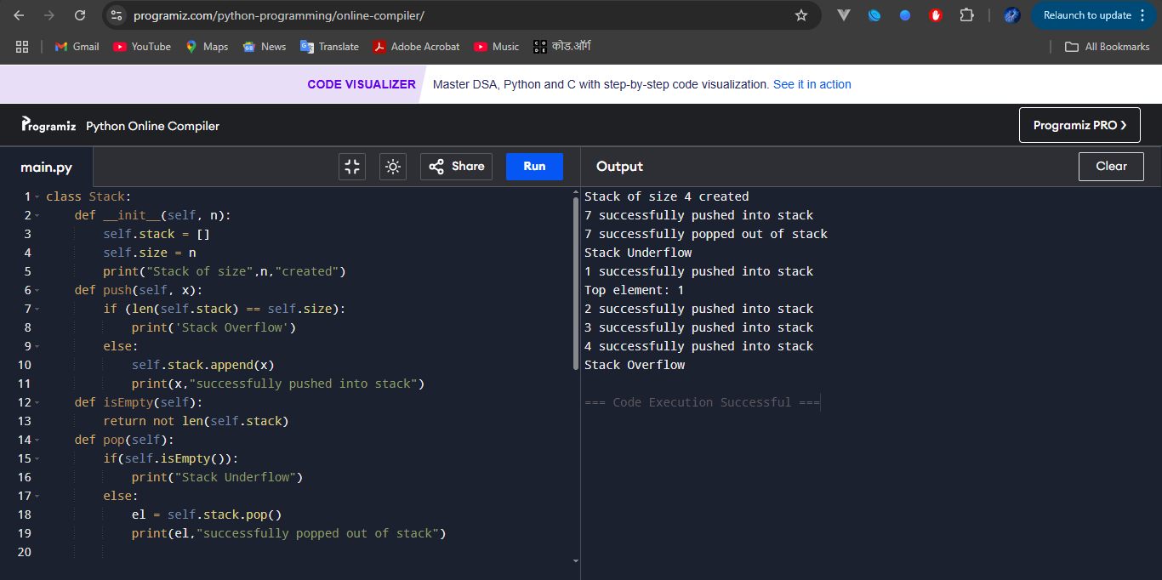

Question 2: Valid Parentheses

Platform: LeetCode

Problem Link: <https://leetcode.com/problems/valid-parentheses/description/>

Submission Screenshot:

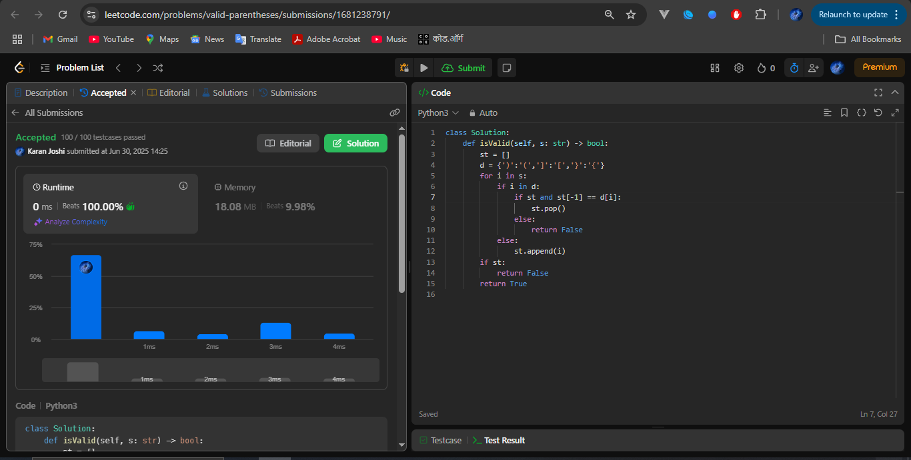

Question 3: Swapping Nodes

Platform: LeetCode

Problem Link: <https://leetcode.com/problems/swapping-nodes-in-a-linked-list/description/>

Submission Screenshot:

